Bootstrap 4

Bootstrap 4 is the newest version of Bootstrap, which is the most popular HTML, CSS, and JavaScript framework for developing responsive, mobile-first websites. Bootstrap 4 is completely free to download and use!

**What is Bootstrap?**

* Bootstrap is a free front-end framework for faster and easier web development
* Bootstrap includes HTML and CSS based design templates for typography, forms, buttons, tables, navigation, modals, image carousels and many other, as well as optional JavaScript plugins
* Bootstrap also gives you the ability to easily create responsive designs

**What is Responsive Web Design?**

Responsive web design is about creating web sites which automatically adjust themselves to look good on all devices, from small phones to large desktops.

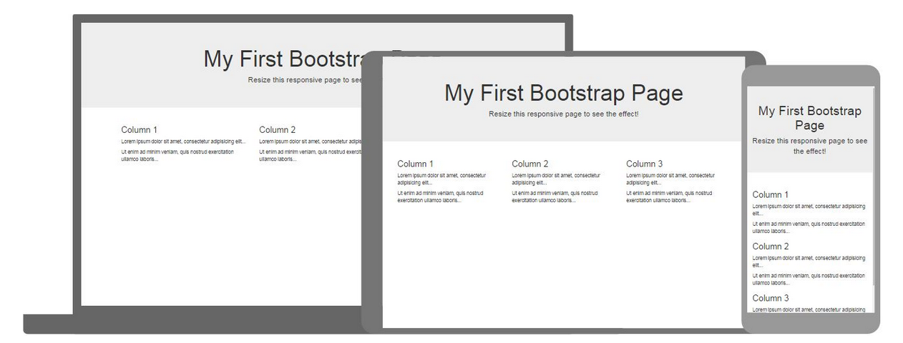

---------------------------------------------------------------------------------------------------------------------------------------------------------------

Open Dreamweaver or any IDE of your choice, if you are using Dreamweaver, please create a folder with today’s date on your desktop, 112519, and define your site in this directory.

1. Select, copy and paste the following code between the head tags.

<head>

<title>Bootstrap Example</title>

<meta charset="utf-8">

<meta name="viewport" content="width=device-width, initial-scale=1">

<link rel="stylesheet" href="https://maxcdn.bootstrapcdn.com/bootstrap/4.3.1/css/bootstrap.min.css">

<script src="https://ajax.googleapis.com/ajax/libs/jquery/3.4.1/jquery.min.js"></script>

<script src="https://cdnjs.cloudflare.com/ajax/libs/popper.js/1.14.7/umd/popper.min.js"></script>

<script src="https://maxcdn.bootstrapcdn.com/bootstrap/4.3.1/js/bootstrap.min.js"></script>

</head>

2. In the body tags, please type the following code:

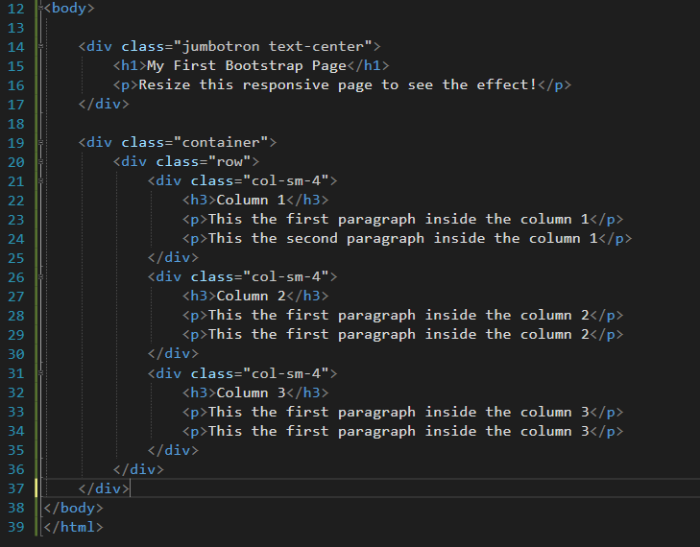

3. In the tool bar, File > Save As**, Bootstrap4.html**.

4. Using the Snipping Tool, take a screen of your webpage, copy/paste below:

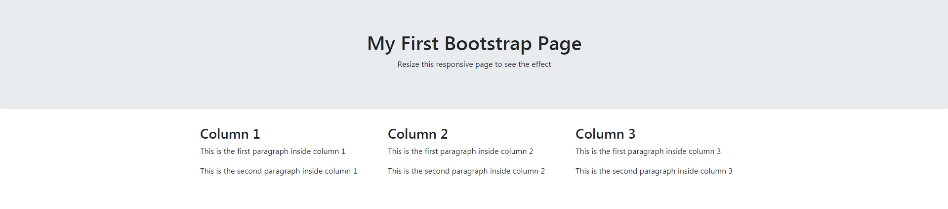

5. Link this **Bootstrap1.html** webpage from your **project.html.**

6. Upload this page to eCampus.